Use the following steps to self-enroll in the 2016 Ancillary Competency Skills Fair.

- Log into MARS and click LMS SuccessFactors under “My Learning”.

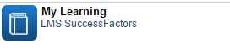
- If this is your first time logging in the new LMS, you may be asked to enter a “new pin”.
Make up a number that you can remember. If not, proceed to step #3.
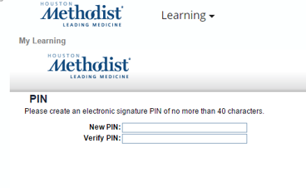
- Go to the top left corner of the screen and click on the drop down arrow next to the word “Home” then you will see “Learning”.

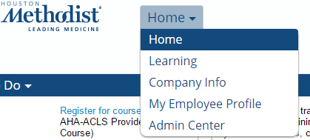

- On the learning page look for the “Find Learning” search box on the right side of the screen.
- Type the word “comps” in the search box
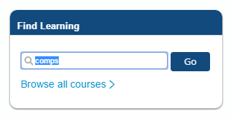
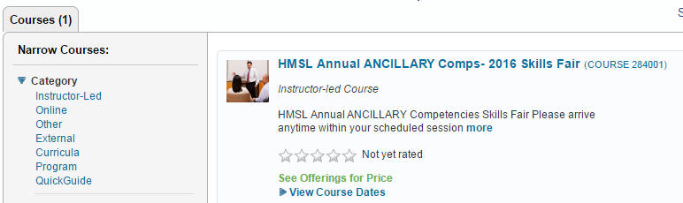

- CLICK on “View Course Dates”
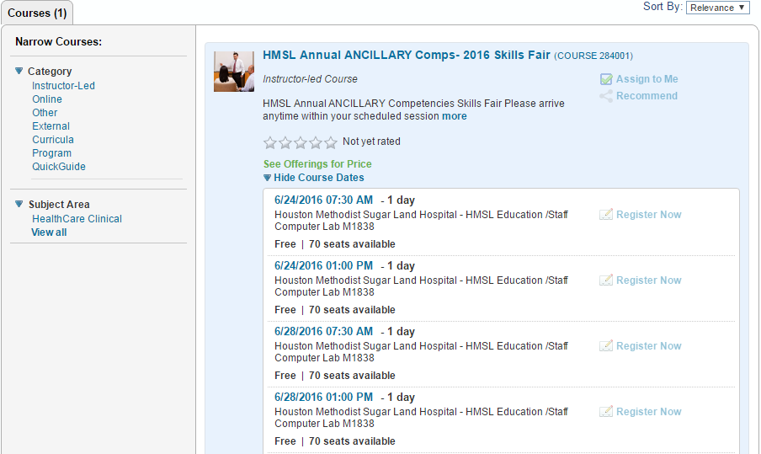

- You will see a list of session dates, times and location. There are 2 session each day. Session 1 7:30am- 11:30am and Session 2 1pm- 5pm. Each session will accommodate 70 people. Click “Register Now” when it appears on the right side of the box. *(this prompt will appear when you move cursor)* Remaining seats available will be displayed at the bottom of each session.

- You will see the registration screen below. Click confirm and complete the enrollment process.

